BSc in Information Systems and Information Technology

Interface Design and Web Development

Shane Kelly
D17124423

School of Computer Science,
Technological University Dublin,
Kevin Street,
Dublin 8, Ireland.

Web Assignment 1

01/04/2019

DECLARATION OF OWN WORK

I declare that this work, which is submitted as part of my course work, is entirely my own, except where clearly and explicitly stated.

Planning Analysis: Write a Planning Analysis (e.g., Introduction) that includes the following headings:
- Web Site Goal
- Describe the goal of your web site in one or two sentences.
- List the working title of each page on your web.
List where you will obtain the content (facts, text, graphics, sounds, video) for the web pages you listed above.

Website Goal
The goal of the website is to turn my CV into a website with a page for each section of the CV.
There are four pages with the following titles:
- Home Page
- Work History
- Education History
- Skills
The information for the site has been pulled from my CV, and the pictures/logos for the colleges on the education history page and employers on the work history page were taken from the banners on the associated website.
Site Map
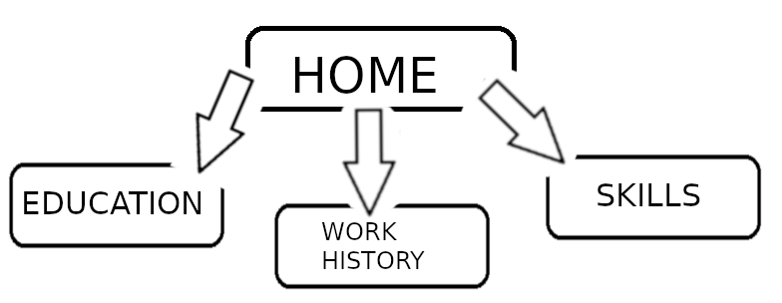
Home page is the landing page, which then leads to the other pages on the navigation bar.

Wireframe (Design):

The Red at the top is the banner, which is the same on each page and has contact information
The blue underneath this is the navigation bar which is the same on each page and has links to all other pages
The yellow is content, which is unique to each page.
The pink is the footer, which is on the end of each page.

